AUTOMATED EMPLOYEE FACIAL BIOMETRIC ATTENDANCE

A

Report submitted in partial fulfilment of the requirement for the

degree of

B.Tech.

In

###### Computer Science & Engineering

By

##### Himanshi Shukla (2101640100121)

##### Harshita Jadwani (2101640100120)

##### Rishika Aggarwal (2101640100217)

##### Under the guidance of

##### (Ms.Neha Singh)

##### (Assistant Professor)

##### Project Id:22_CS_2A_18



Pranveer Singh Institute of Technology, Kanpur

Dr A P J A K Technical University

Lucknow

## DECLARATION

This is to certify that Report entitled “Automated Employee Facial Biometric Attendance”which is submitted by me in partial fulfilment of the requirement for the award of degree B.Tech. in Computer Science and Engineering to Pranveer Singh Institute of Technology, Kanpur Dr. A P J A K Technical University, Lucknow comprises only our own work and due acknowledgement has been made in the text to all other material used.

#### Date:

Himanshi Shukla (2101640100121)

Harshita Jadwani (2101640100120)

Rishika Aggarwal (2101640100217)

## 

## 

## Certificate

This is to certify that Report entitled “Automated Employee Facial Biometric Attendance” which is submitted by Himanshi Shukla (2101640100121), Harshita Jadwani (2101640100120), Rishika Aggarwal (2101640100217) in partial fulfilment of the requirement for the award of degree B.Tech. in Computer Science & Engineering to Pranveer Singh Institute of Technology, Kanpur affiliated to Dr. A P J A K Technical University, Lucknow is a record of the candidate own work carried out by him under my supervision. The matter embodied in this thesis is original and has not been submitted for the award of any other degree.

|  |  |  |
| --- | --- | --- |
| Signature:     Dr. Vishal Nagar  Dean CSE Department,  PSIT, Kanpur |  | Signature:  Name of Supervisor  Designation  CSE Department,  PSIT, Kanpur |
|  |  |  |

***ACKNOWLEDGEMENT***

*It gives us a great sense of pleasure to present the report of the B.Tech. Project undertaken during B.Tech. Second Year. We owe special debt of gratitude to our project supervisor Ms.Neha Singh (Assistant Professor), Department of Computer Science and Engineering, Pranveer Singh Institute of Technology, Kanpur for her constant support and guidance throughout the course of our work. Her sincerely, thoroughness and perseverance have been a constant source of inspiration for us. It is only her cognizant efforts that our endeavours have seen light of the day.*

*We also take the opportunity to acknowledge the contribution of Professor Dr. Vishal Nagar, Dean Computer Science & Engineering Department, Pranveer Singh Institute of Technology, Kanpur for his full support and assistance during the development of the project.*

*We also do not like to miss the opportunity to acknowledge the contribution of all faculty members of the department for their kind assistance and cooperation during the development of our project. Last but not the least, we acknowledge our friends for their contribution in the completion of the project.*

*Signature: Signature:*

*Name:Himanshi Shukla Name:HarshitaJadwani*

*Roll No.2101640100121 Roll No.2101640100120*

*Signature:*

*Name:Rishika Aggarwal*

*Roll No.2101640100217*

***ABSTRACT***

**Reason**

Pandemics such as Covid 19 can be better managed if physical contact is minimized in public and work environments. It is possible to minimize the risk of virus spread in multi-tenant environments and workplaces by reducing the frequency of contact between individuals by them.

Attendance systems based on artificial intelligence are much more automated than manual ones. Records are stored and updated in real-time by these systems. From maintaining daily attendance to preparing high-accurate timesheets of individual employees, facial recognition attendance systems are programmed to handle it on a considerable scale.

In the post-pandemic era, a face recognition-based smart attendance system is a modern convenience needed even today. By tracking employee and student attendance accurately, these systems save employers and schools money. Adding such a system to the workplace and schools would also add a layer of security. Using facial recognition-based smart systems is today’s most effective solution.

**Main Findings**

The biometric facial recognition system allows employees to go to work without personally putting down their personal belongings. They just need to stand in front of the device and wait to be recognized. Once the system recognizes their facial features, it immediately records their attendance. Make it easy for your employees to record their attendance and entry to the premises without intervention.

Contactless biometric attendance face recognition system not only allows you to keep track of your employees’ accurate working hours, but it also helps in improving and tightening existing security measures. Other than employees, you can also add the details of visitors that come to your premises from time to time. Any person who could not be found in the system will be denied access. A face recognition system can also provide evidence in case any untoward or illegal event happens and authorities come to investigate.

Artificial intelligence-based attendance is an automated system, which makes it a lot easier to track employees’ time. There is no need to keep an eye on employees during all their hours on the premises. This technology can accurately and quickly deliver the information about the attendance, absence, and overtime of every employee.

Buddy punching is one of the serious issues which are happening while having less security. Generally, most of the employees will try to save their buddies to get full attendance by punch instead of them. But when it comes to face recognition in Biometric Attendance System, one could not able to make it possible. Therefore it is really the best technique to follow

**TABLE OF CONTENTS**

**TITLE PAGE NO.**

1)Cover and Tittle Page 1

2)Decalaration 2

3)Certificate 3

4)Acknowledgements 4

5)Abstract 5

6)LIST OF ABBREVIATIONS 8

**CHAPTER 1** (INTRODUCTION) 9

1.1 MOTIVATION 9

1.2 BACKGROUND OF PROBLEM 10

1.2.1 CURRENT SYSTEM 10

1.2.2 ISSUES IN CURRENT SYSTEM 10

1.2.1 FUNCTIONALITY ISSUES 10

1.2.2 SECURITY ISSUES 10

1.3 PROBLEM STATEMENT 11

1.4 PROPOSED WORK 11

**CHAPTER 2**(DESIGN METHODOLOGY) 13

**CHAPTER 3** (IMPLEMENTATION) 14

**CHAPTER 4** (TESTING/RESULT AND ANALYSIS) 16

**CHAPTER 5** (CONCLUSION AND FUTURE ENHANCEMENTS) 21

**REFRENCES** 23

**LIST OF ABBREVIATIONS AND NOMENCLATURE**

**ABBREVIATION NOMENCLATURE**

1.GUI Graphical User Interface

2.Hrc Haar Cascade

3.RFID radio frequency identification biometrics

4.OpenCV Open-Source Computer Vision Library

5.LBPH Local Binary Pattern Histogram

**CHAPTER 1: INTRODUCTION**

Face recognition is the task of identifying an already detected object as a known or unknown face. Often the problem of face recognition is confused with the problem of face detection. Face Recognition on the other hand is to decide if the "face" is of someone known, or unknown, using for this purpose a database of faces in order to validate this input face. The face is one of the easiest ways to distinguish the individual identity of each other. Face recognition is a personal identification system that uses personal characteristics of a person to identify the person's identity. Human face recognition procedure basically consists of two phases, namely face detection, where this process takes place very rapidly in humans, except under conditions where the object is located at a short distance away, the next is the introduction, which recognize a face as individuals. Stage is then replicated and developed as a model for facial image recognition (face recognition) is one of the much-studied biometrics technology and developed by experts. The “Automated Employee Facial Biometric Attendance” is a desktop application that has its frontend developed using GUI (Python Library) and backend model trained and developed using (Deep Learning and Machine Learning Algorithms of face Recognition).

There will be a user login page for the managing authority to prevent false entries. This desktop application will keep a record of the entries and exits (from the premises) as well as details of the employee .The new entries along with photo samples can also be taken using this application.

The face Recognition model has been built using OpenCV library of python and trained using Hrc algorithim and details will be stored using MySQL database.

* 1. **MOTIVATION**

The main motivation for this project was the slow and inefficient traditional manual attendant system. So, why not make it automated fast and much efficiently. Also, such face detection techniques are in use by department of criminal investigation were the usage of CCTV footages and detecting the faces from the Crime Scene and comparing them with criminal database to recognise them. It is also becoming as a feature of daily life in China, where authorities are using it on the streets, in Subway stations, and at airports.

* 1. **BACKGROUND OF PROBLEM**

The current method that organizations uses is the boss passes an attendance sheet or uses biometric system and mark the attendance of employee which sometimes disturb the discipline of the organizations and this sheet further goes to the control department which then uploads it to an excel sheet. This process is quite hectic and time consuming also for control staff or employees at organization the facial biometric system serves once at a time so why not shift to an attendance system which works on face recognition technique?

**Current System**

At present attendance marking involves manual attendance on the paper sheet by by the control department but it is very time consuming process and chances of proxy or also an issue that arises in such type of attendance marking. Also there is an attendance marking system such as RFID etc but the systems are currently not that popular for the employees.

* + 1. **Issues in Current System**

**1.2.2.1 Functionality Issues**

1. Manual Systems put pressure on people to be correct in all details of their work at all times, the problem being that people aren’t perfect, however, each of us wishes we were.
2. These attendance systems are manual
3. More manpower is required.
4. Calculations related to attendance are done manually(total days attended in a month)which are prone to error.
5. It is difficult to maintain a database or register in manual systems.

**1.2.2.2 Security Issues**

1. There is always a chance of leak of personal details(Security Issue).
2. There is always a chance of forgery(one person signing the presence of the other one) Since these are manually so there is a great risk of error.
   1. **PROBLEM STATEMENT**

To develop an automatic attendance system using face recognition concept in a large number of employees it is very difficult and time consuming task to take attendance manually therefore we can implement an effective system which will mark the attendance of employees automatically by recognising their faces. The process of this Automated employee facial biometric attendance software is divided into various steps but the important steps are detection of face and recognition of face firstly to mark the attendance of the employee the image of employees faces will be required this image can be captured from the camera device which will be placed at a suitable location in a from where the face can be clearly recognised this image will act as an input to the system for the effective face recognition the image need to be enhanced by using some image processing techniques like gray scale conversion of image and histogram equalization to identify employee the histogram equalization of image needs to be done hence there is a need to develop a real time operating employee automatic attendance system which means the identification process must be done within define time constraints to prevent omission the extracted features from facial images which represents the identity of the employee have to be consistent toward a change in background illumination pose and expression high accuracy and fast computation time will be the evaluation points of the performance.

**1.4 Proposed Work**

All the employees must register themselves by entering the required details and then their images will becaptured and stored in the dataset. During each session, faces will be detected from live streaming video of classroom. The faces detected will be compared with images present in the dataset. If match found, attendance will be marked for the respective employee.At the end of each session, list of absentees will be mailed to the respective faculty handling the session. The system architecture of the proposed system is given below, Typically this process can be divided into four stages,

1.Dataset Creation

Images of employee are captured using a web cam. Multiple images of single employee will be acquired with varied gestures and angles. These imagesundergo pre-processing. The images are cropped to obtain the Region of Interest (ROI) which will be further used in recognition process. Next step is to resize the cropped images to particular pixel position. Then these images will be converted from RGB to gray scale images. And then these images will be saved as the names of respective employee in a folder.

2.Face Detection

Face detectionhere is performed using Haar-Cascade Classifier with OpenCV. Haar Cascade algorithm needs to be trained to detect human faces before it can be used for face detection. This is called feature extraction. The haar cascade training dataused is an xml file- haarcascade_frontalface_default. Here we are using detectMultiScale module from OpenCV. This is required to create a rectangle around the faces in an image. It has got three parameters to consider- scaleFactor, minNeighbors, minSize. scaleFactor is used to indicate how much an image must be reduced in each image scale. minNeighbors specifies how many neighbors each candidate rectangle must have. Higher values usually detects less faces but detectshigh quality in image. minSizespecifiesthe minimum object size. By defaultit is (30,30) [8]. The parameters usedin this system is scaleFactorand minNeighbors with the values 1.3 and 5 respectively.

3.Face Recognition

Face recognition process can be divided into three steps- prepare training data, train face recognizer, prediction. Here training data will be the images present in the dataset. They will be assigned with a integer label of the employee it belongs to. These images are then used for face recognition. Face

recognizer usedin this system is Local Binary Pattern Histogram. Initially, the list of local binary patterns (LBP) of entire faceis obtained. These LBPs are converted into decimal number and then histograms of all those decimal values are made. At the end, one histogram will be formed for each images in the training data. Later, during recognition process histogram of the face to be recognized is calculated and then compared with the already computed histograms and returns the best matched label associated with the employee it belongs to organization

4.Attendance Updation

After face recognition process, the recognized faces will be marked as present in the excel sheet and the rest will be marked as absent and the list of absentees will be mailed to the respective faculties. Control Authoritieswill be updatingwith monthly attendance sheet at the end of every month.

.

**CHAPTER 2:DESIGN METHODOLOGY**

A GUI is created for the user to register and login and a database is created using SQL Workbench to store the details and photo samples of the employees. As a new employee comes his/her images are captured and stored in database .Then the model is build using LBPH Algorithm and trained using HaarCascade Algorithm. The Project errors are rectified and then the desktop application of the project is created.



Designing a GUI

, Registration and

login page.



Creating a database to store the details

of employees

.



Capturing images and storing

details of employees

.



Training model using Haar Cascade

and LBPH Algorithm.



Fixing errors.



Creating a

desktop

application.

**CHAPTER 3:Implementation**

**4.1 HaarCascade Algorithm**

It is a machine learning based approach where a cascade function is trained from a lot of

positive and negative images (where positive images are those where the object to be

detected is present, negative are those where it is not). It is then used to detect objects in

other images. Luckily, OpenCV offers pre-trained Haar cascade algorithms, organized

into categories (faces, eyes and so forth), depending on the images they have been trained

on.

It is a machine learning based approach where a cascade function is trained from a lot of

positive and negative images (where positive images are those where the object to be

detected is present, negative are those where it is not). It is then used to detect objects in

other images. Luckily, OpenCV offers pre-trained Haar cascade algorithms, organized

into categories (faces, eyes and so forth), depending on the images they have been trained

on.

It is a machine learning based approach where a cascade function is trained from a lot of

positive and negative images (where positive images are those where the object to be

detected is present, negative are those where it is not). It is then used to detect objects in

other images. Luckily, OpenCV offers pre-trained Haar cascade algorithms, organized

into categories (faces, eyes and so forth), depending on the images they have been trained

on.

It is a machine learning based approach where a cascade function is trained from a lot of

positive and negative images (where positive images are those where the object to be

detected is present, negative are those where it is not). It is then used to detect objects in

other images. Luckily, OpenCV offers pre-trained Haar cascade algorithms, organized

into categories (faces, eyes and so forth), depending on the images they have been trained

on.

It is a machine learning based approach where a cascade function is trained from a lot of

positive and negative images (where positive images are those where the object to be

detected is present, negative are those where it is not). It is then used to detect objects in

other images. Luckily, OpenCV offers pre-trained Haar cascade algorithms, organized

into categories (faces, eyes and so forth), depending on the images they have been trained

on.

It is a machine learning based approach where a cascade function is trained from a lot of positive and negative images (where positive images are those where the object to be detected is present, negative are those where it is not). It is then used to detect objects in otherimages. Luckily, OpenCV offers pre-trained Hrc algorithms, organized into categories (faces, eyes and so forth), depending on the images they have been trained on.

**4.2 LBPH Algorithm**

Local Binary Pattern (LBP) is a simple yet very efficient texture operator which labels the pixels of an image by thresholding the neighborhood of each pixel and considers the result as a binary number. It has further been determined that when LBP is combined with histograms of oriented gradients (HOG) descriptor, it improves the detection performance considerably on some datasets.

**4.3 OpenCV Library**

OpenCV (Open-Source Computer Vision Library) is an open-source computer vision and

machine learning software library. OpenCV was built to provide a common infrastructure

for computer vision applications and to accelerate the use of machine perception in the

commercial products. Being a BSD-licensed product, OpenCV makes it easy for

businesses to utilize and modify the code.

OpenCV (Open-Source Computer Vision Library) is an open-source computer vision and

machine learning software library. OpenCV was built to provide a common infrastructure

for computer vision applications and to accelerate the use of machine perception in the

commercial products. Being a BSD-licensed product, OpenCV makes it easy for

businesses to utilize and modify the code.

OpenCV (Open-Source Computer Vision Library) is an open-source computer vision and machine learning software library. OpenCV was built to provide a common infrastructure for computer vision applications and to accelerate the use of machine perception in the commercial products. Being a BSD-licensed product, OpenCV makes it easy for businesses to utilize and modify the code.

**4.4 NumPy package**

NumPy is a Python package which stands for 'Numerical Python'. It is the core library for

scientific computing, which contains a powerful n-dimensional array object, provide tools

for integrating C, C++ etc. It is also useful in linear algebra, random number capability

etc.

NumPy is a Python package which stands for 'Numerical Python'. It is the core library for scientific computing, which contains a powerful n-dimensional array object, provide tools for integrating C, C++ etc. It is also useful in linear algebra, random number capability etc.

**4.5 Pandas Library**

Pandas is a high-level data manipulation tool developed by Wes McKinney. It is built on the NumPy package and its key data structure is called the Data Frame. Data Frames allow you to store and manipulate tabular data in rows of observations and columns of variables.

**4.6 Tkinter Module**

Tkinter is the standard GUI library for Python. Python when combined with Tkinter provides a fast and easy way to create GUI applications. Tkinter provides a powerful object-oriented interface to the Tk GUI toolkit .

**4.7 Time Module**

Python has a module named time to handle time related task. To use functions defined in the module, we need to import the module first.

**4.8 Date Time Module**

A date in python is not a date type of its own, but we can import a module named date time work with dates as a date objects.

**CHAPTER 4: TESTING/RESULT AND ANALYSIS**

The interface for the Smart Attendance System has been created. Using the interface the images of the individual students is being recorded and stored in the training dataset. Simultaneously their information is stored in the database i.e. excel sheet. Finally the images of the students is being tracked and recognized.

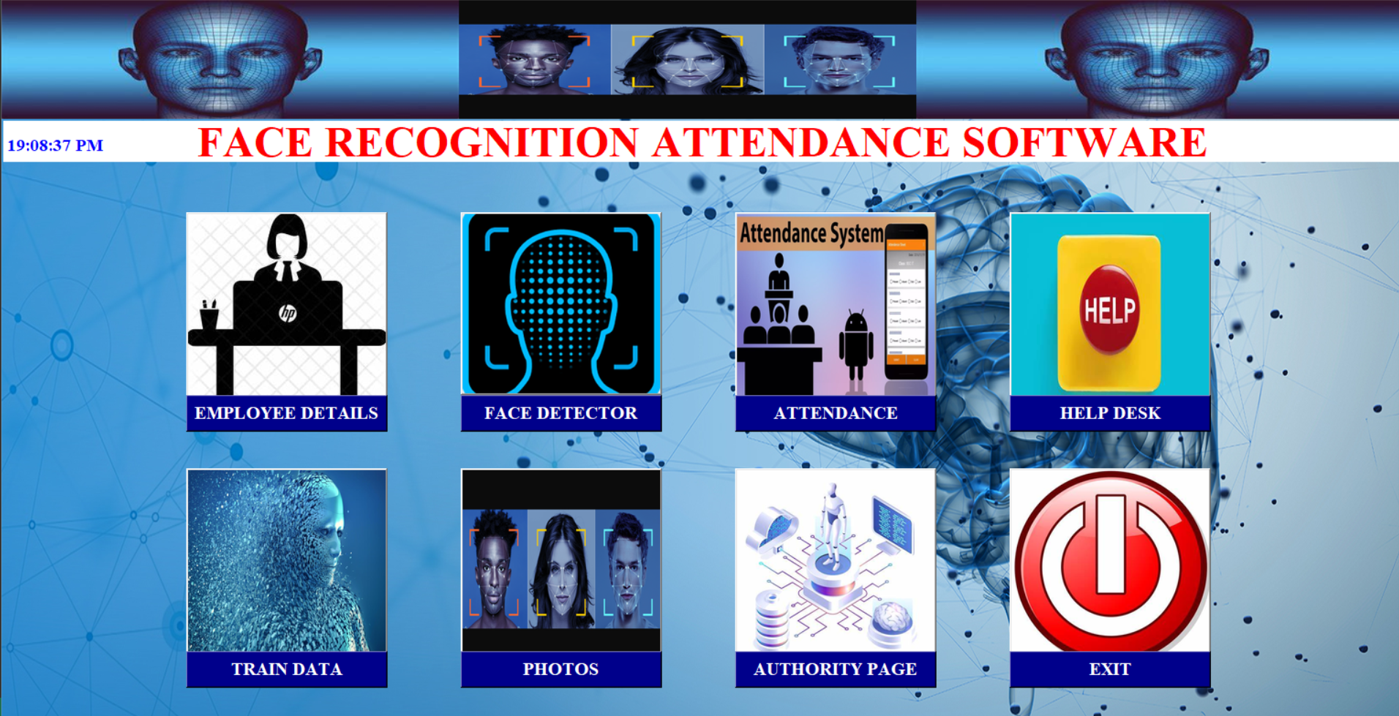

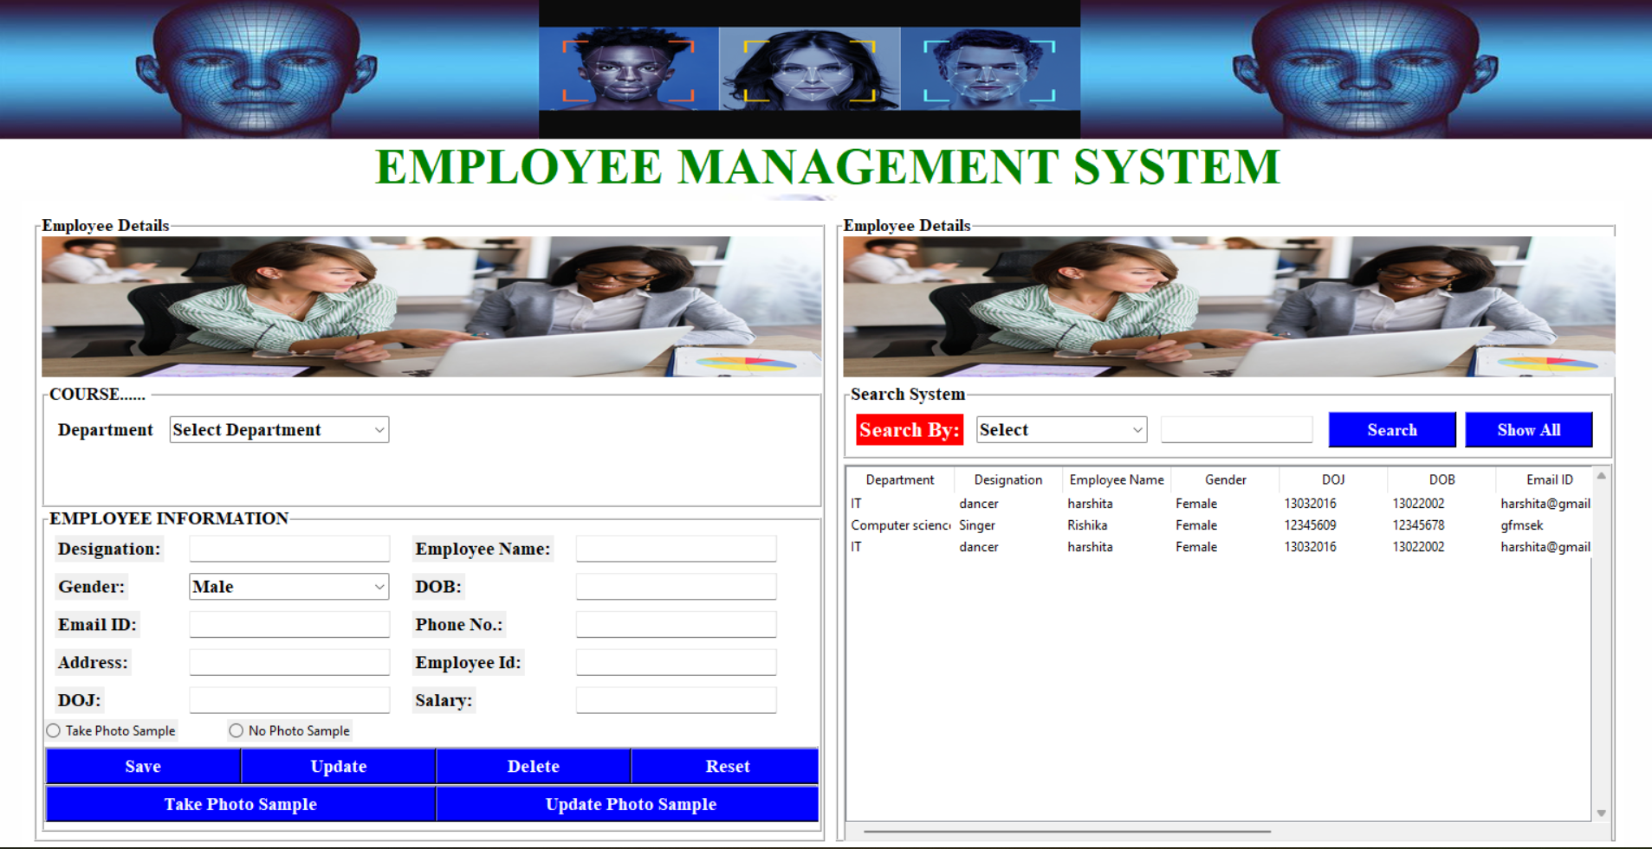

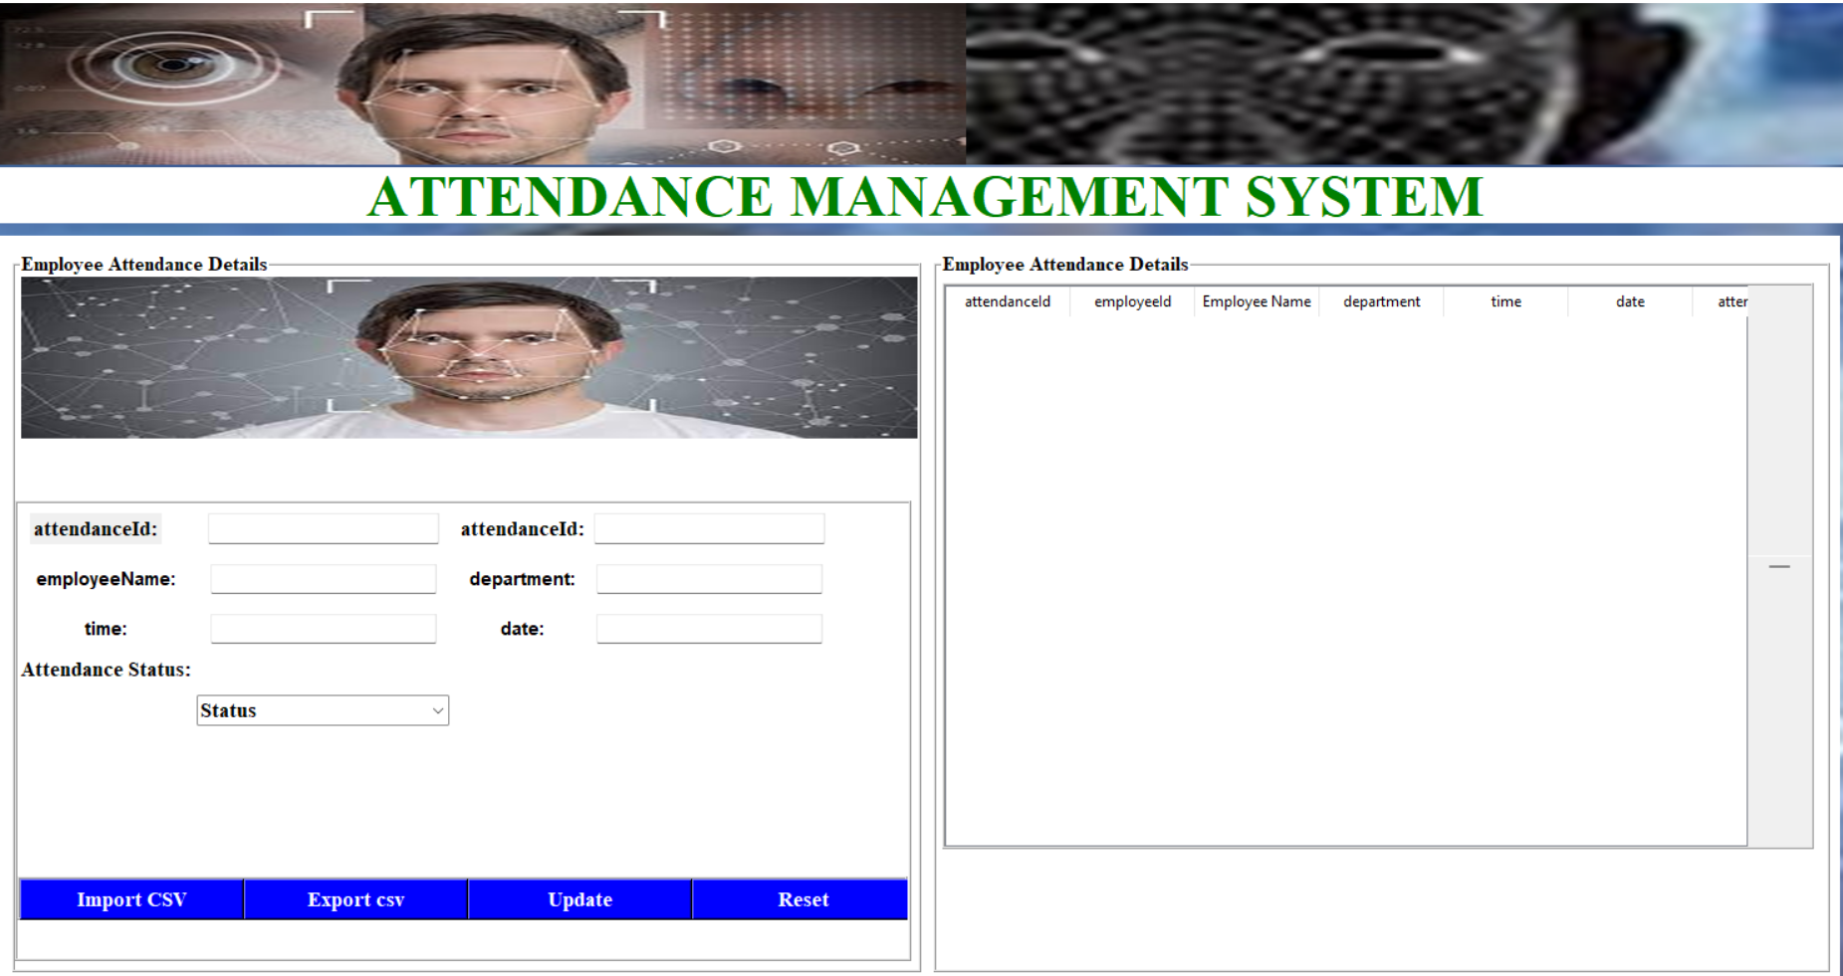



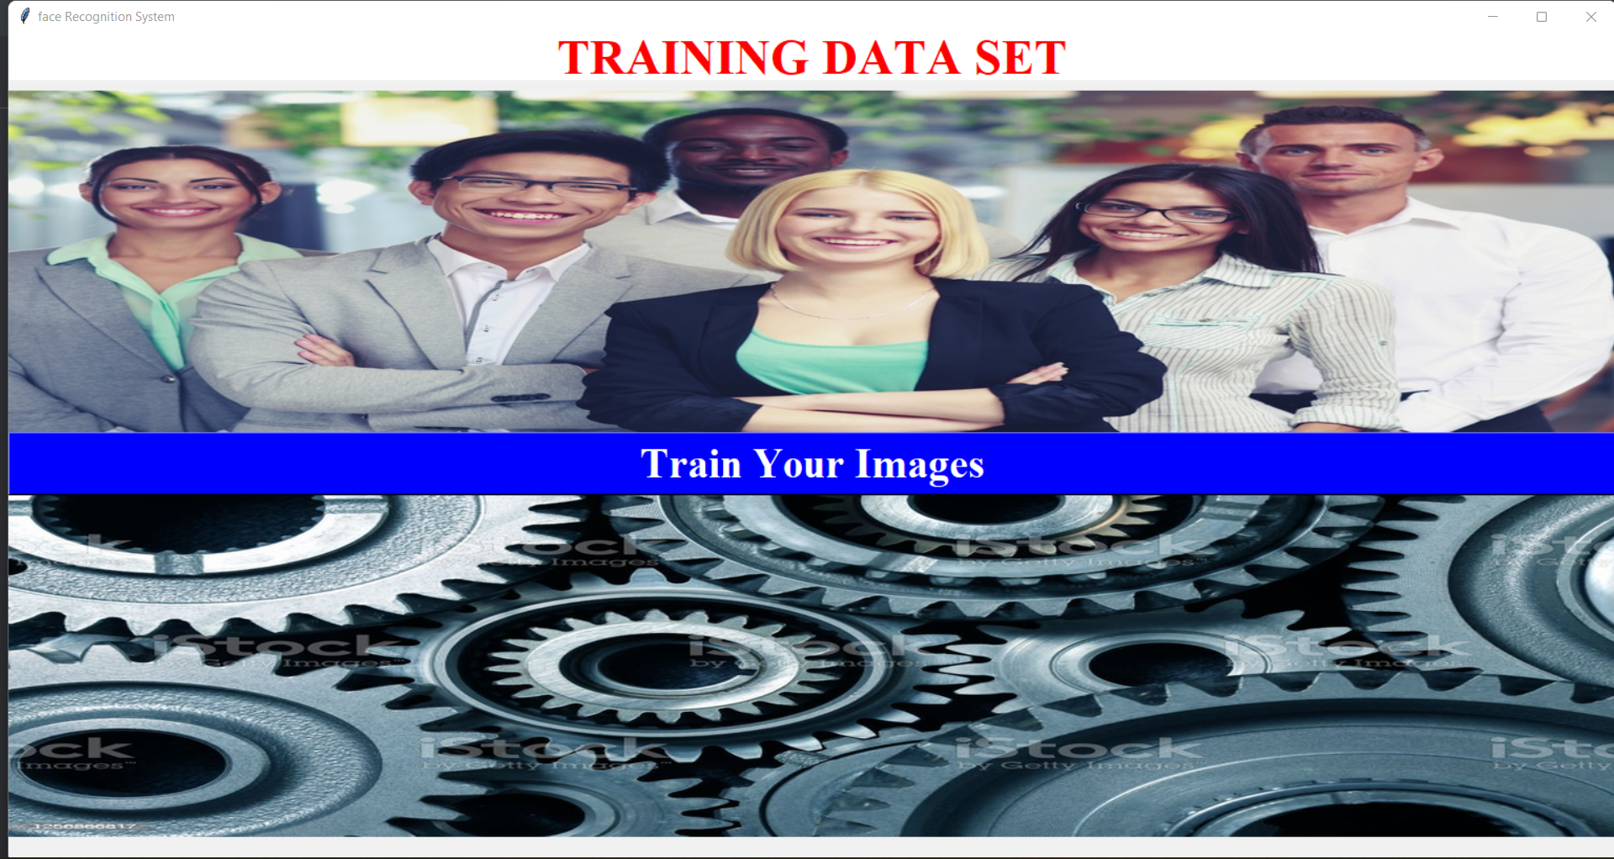

**CHAPTER 5: CONCLUSION AND FUTURE ENHANCEMENTS**

**5.1 Conclusion**

In the post-pandemic era, a face recognition-based smart attendance system is a modern convenience needed even today. By tracking employee and student attendance accurately, these systems save employers and schools money. Adding such a system to the workplace and schools would also add a layer of security. Using facial recognition-based smart systems is today’s most effective solution.

In this Automated Employee Facial Biometric Attendance thoroughly describes the proposed approach provides a method to identify the individuals by comparing their input image obtained from recording video frame with respect to train image. This proposed approach is able to detect and look for face from an input facial image which is obtained from recording video frame beside it provides a method in pre processing stage to enhance the image contrast and reduce the illumination effect extraction of features from the facial images is performed by applying both LBPH algorithm and Hrc algorithm. The algorithm gives the accuracy of this proposed solution as 77%.

In order to maintain the attendance this system has been proposed it replaces a manual system with an automated system which is fast efficient cost and time saving as it replaces the stationery material and the paper work has the system is expected to give desired results and in future could be implemented for long run also the efficiency could be improved by integrating other techniques with in it in your future in this system we have implemented and attendance records to assist the employees it says times and efforts specially if it is to deal with a large number of employees automated attendance system has been vision for the purpose of reducing the drawbacks in the traditional or the manual system. This method is secure enough reliable and available for use no need for specialised hardware for installing the system in the office it can be constructed using a camera and a computer this attendant system demonstrate the use of image processing techniques this system cannot only mainly help in attendance system but will also improve the Goodwill of the organisation

his method is secure enough, reliable and available for use. No need for

specialized hardware for installing the system in the office. It can be constructed using a

camera and computer.

his method is secure enough, reliable and available for use. No need for

specialized hardware for installing the system in the office. It can be constructed using a

camera and computer.

his method is secure enough, reliable and available for use. No need for

specialized hardware for installing the system in the office. It can be constructed using a

camera and computer.

**5.2 Future Enhancements**

It can be easily implemented in any organisation a method could be proposed to illustrate robbustness against the variations that is in near future we could built a system which would be robust and would work in undesirable conditions too here it is proposed for an organisation to take the attendance of the employees but in future can also be used to do the same work at entry as well as at exit points we are working to improve the face recognition effectiveness to build more efficient system in the near future in further work to improve face recognition effectiveness by using the interaction among our system the users and the administrators on the other hand are system can be used in a completely new dimensions of face recognition application mobile face recognition which can be aid for common people to know about any person being photographed by cell phone camera including proper authorisation for accessing a centralised database.

**REFERENCES**

1. Google
2. [www.youtube.com](http://www.youtube.com)
3. <https://www.github.com>
4. [www.geeksforgeeks.com](http://www.geeksforgeeks.com)
5. Wikipedia
6. <https://www.openCV.org>
7. [(PDF) Attendance system with face recognition and image processing (AI and ML) using Python (researchgate.net)](https://www.researchgate.net/publication/368660934_Attendance_system_with_face_recognition_and_image_processing_AI_and_ML_using_Python)